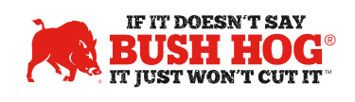

TO: Bush Hog Dealers

FROM: Kerry Meacham

SUBJECT: Additional Bush Hog Customer Satisfaction Training, When You Want It!!!

DATE: March 1, 2022

Dear Bush Hog Dealer,
We kicked off the Bush Hog Customer Satisfaction Program in November of last year with training for our dealers on Aimbase. This allows you to see what your customers think about Bush Hog products and their experience with your dealership during the buying process. However, we know several people had difficulty scheduling time with the trainer. In an effort to provide easier access to this information, we have a video training session
and if an issue that needs resolution, step-by-step instructions for how to manage the situation.

If you have any questions, please contact our partners at csisupport@rollick.io. They will be happy to help in any way.

We hope this program provides you a way to better serve your Bush Hog customers in 2022. Thank you for your continued support.

Stay Safe and Be Healthy!

Kerry Meacham

Vice-President Sales & Marketing
Bush Hog, Inc.

