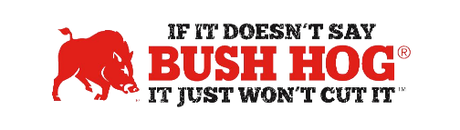
North Carolina Sheriff Association Contract
Contract No. 24-08-0421
Expiration Date May 17, 2024

Contract Details
- Contract Name Heavy Equipment
- Contract Number 24-08-0421
- Contract Held by Bush Hog LLC
- Multiple Award Yes
- PO Submission Bush Hog only
- Coverage Area North Carolina & Virginia
- Products Covered All Mower products except Rear Mount Booms
All Snow Blowers, Road Graders, Hay Tools, Lift Disc Harrows, Aerators, Rear Blades, Tillers
- Freight Terms FOB Destination added as separate line items
- Warranty Terms Standard Factory
- Financing Only if made available by supporting dealers
- Trade-In Only if made available by supporting dealers
- Returns Only if made available by supporting dealers

For further assistance, contact your Territory Manager, Lance Wheeler, Mary Andrews, or Jill Sandidge.

Lance Wheeler
Business Development Manager
Lance.wheeler@bushhog.com
469-745-3402

Mary Andrews Jill Sandidge
Contract Manager Contract Administrator
mary@manufacturerssolutionsteam.com jill@manufacturerssolutionsteam.com
830-481-4818 615-680-4458

