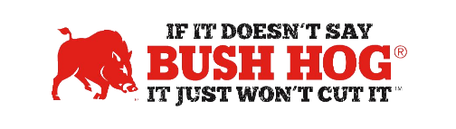

Oklahoma Statewide Contract
Contract No. SW0196
Expiration Date March 13, 2028

Contract Details
- Contract Name Agriculture, Trees, and Brush Maintenance Equipment, Attachments,
Accessories, Parts, and Services
- Contract Number SW0196
- Contract Type Statewide
- Contract Held by Bush Hog LLC
- Multiple Award Yes
- PO Submission Bush Hog and Dealers Registered with the Office of Management &
Enterprise Service
- Coverage Area State of Oklahoma
- Products All Products
- Freight Terms FOB Destination, Freight, Set-up and PDI quoted separately
- Warranty Terms Standard Factory Warranty
- Payment Terms Net 45 days
- Term of Contract Initial Term 1-Year, (4) 1-Year Extension Options
- Financing Only if made available by supporting dealers
- Trade-In Only if made available by supporting dealers
- Returns Only if made available by supporting dealers

For further assistance, contact your Territory Manager, Lance Wheeler, Mary Andrews, or Jill Sandidge.

Lance Wheeler
Business Development Manager
Lance.wheeler@bushhog.com
469-745-3402

Mary Andrews Jill Sandidge
Contract Manager Contract Administrator
mary@manufacturerssolutionsteam.com jill@manufacturerssolutionsteam.com
830-481-4818 615-680-4458

