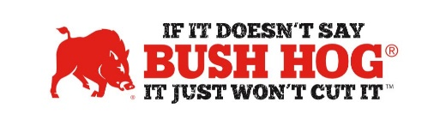
BuyBoard Cooperative Purchasing Contract
Contract No. 706-23
Expiration Date May 31, 2026

Contract Details
- Contract Name Grounds Maintenance Equipment, Irrigation Parts, Supplies Installation
- Contract Number 706-23
- Contract Held By Bush Hog LLC
- Multiple Award Yes
- PO Submission Issued to authorized dealers or Bush Hog
All POs must go to BuyBoard for processing
- Coverage Area US
- Products Covered All Bush Hog Products
- Freight Terms Prepay and Add Delivered to Destination, Added as a Separate Line
- Warranty Terms Standard Bush Hog Warranty
- Payment Terms Net 30 days

For further assistance, contact your Territory Manager, Mary Andrews, Jill Sandidge, or Shellee Lolley Bullard.

Mary Andrews Jill Sandidge
Contract Manager Contract Administrator
mary@manufacturerssolutionsteam.com jill@manufacturerssolutionsteam.com
830-481-4818 615-680-4458

Shellee Lolley Bullard
Customer Service
Shellee.lolley@bushhog.com
334-874-2723

