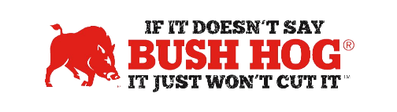
Commonwealth of PA DGS/COSTARS
Contract No. 4400028311
Expiration Date December 31, 2029

Contract Details
- Contract Name Ag / Grounds Keeping Type Power Eqpt.
- Contract Number 4400028311
- Contract Held By Bush Hog LLC
- Multiple Award Yes
- PO Submission Bush Hog only
- Coverage Area Commonwealth of PA, & COSTARS Members. List of COSTARS members
can be found at http://www.costars.state.pa.us/SearchCOMember.aspx
- Products Covered All Mower Products, Landscape, Construction & Snow Products
- Freight Terms FOB Destination, Freight, Set-up and PDI quoted separately.
- Surcharge NA
- Warranty Terms Standard Bush Hog Warranty
- Payment Terms Not specified, Use of P-Card up to $10,000
- Price Changes Allowed No changes required, currently published price book in effect at all times.
- Term of Contract Valid From: 01/01/2024 To: 12/31/2025.
May be renewed for up to 4 additional 1-Year Terms

Contract Pricing
- Price Book Currently published price book always in effect. No price book submitted.
- Freight Rates Bush Hog Current Rates
- Volume Discount Allowable, but none stipulated on contract.
- Financing Through Dealer
- Trade-In Through Dealer
- Returns Through Dealer

