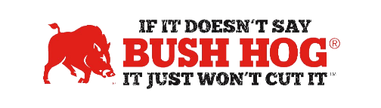

Kansas Landscaping, Lawn & Ag Equipment
Contract No. 53336, EVT0008926
Expiration Date February 29,2025 (2028)

Contract Details
- Contract Name Landscaping, Lawn, & Agricultural Equipment
- Contract Number 53336, EVT0008926
- Contract Held by Bush Hog LLC
- Multiple Award Yes
- PO Submission Bush Hog
- Coverage Area KS State Agencies
- Products Covered Pull behind or 3-point hitch rotary cutters & Agricultural Implements
- Freight Terms Freight must be prepaid and allowed. Freight & Delivery must be quoted with the equipment but can be separate line items.
- Warranty Terms Standard Factory Warranty
- Term of Contract 12 Months with options to extend up to three additional 12-month periods.

For further assistance, contact your Territory Manager, Lance Wheeler, Mary Andrews, or Jill Sandidge.

Lance Wheeler
Business Development Manager
Lance.wheeler@bushhog.com
469-745-3402

Mary Andrews Jill Sandidge
Contract Manager Contract Administrator mary@manufacturerssolutionsteam.com jill@manufacturerssolutionsteam.com
830-481-4818 615-680-4458

