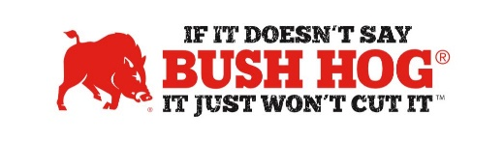
Commonwealth of Kentucky Ground Maintenance Equipment Contract
Contract No. MA 758 2300001363
Expiration Date January 31, 2029

Contract Details
- Contract Name Ground Maintenance Equipment
- Contract Number MA 758 2300001363
- Contract Held By Bush Hog LLC
- Multiple Award Yes
- PO Submission Bush Hog Only
- Coverage Area State of Kentucky
- Products Covered Flex Wings, Multi & Single Spindles, Finishing Mowers, Boom Mowers,
& Crop Flails for Ag Applications
- Freight Terms FOB Destination, Freight, PDI, & Delivery Included in MSRP
- Warranty Terms Standard Bush Hog Warranty
- Payment Terms Net 30 days

For further assistance, contact your Territory Manager, Mary Andrews, Jill Sandidge or Shellee Lolley Bullard.

Shellee Lolley Bullard
Customer Service Representative
shellee.lolley@bushhog.com
800-363-6096 ext 3816

Mary Andrews Jill Sandidge
Contract Manager Contract Administrator
mary@manufacturerssolutionsteam.com jill@manufacturerssolutionsteam.com
830-481-4818 615-680-4458

