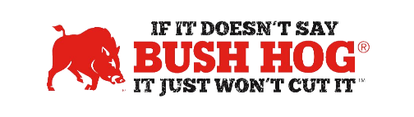
National Cooperative Purchasing Alliance (NCPA) Award
Contract No. 02-106
Expiration Date December 31, 2025

Contract Details
- Contract Name Turf and Grounds Maintenance Equipment, Parts, Accessories, Supplies,
Related Equipment, and Services
- Contract Number 02-106
- Contract Held by Bush Hog LLC
- Multiple Award Yes
- PO Submission NCPA Approved Dealer or Bush Hog (preferably dealer)
- Coverage Area USA
- Products Covered Entire Bush Hog Catalog
- Freight Terms Prepaid, F.O.B. destination
- Warranty Terms Standard Bush Hog Warranty
- Payment Terms Not Specified, Bush Hog standard is Net 60
- Term of Contract Jan 2021 – Dec 2023 - 3 Years, Options for Two Additional 1 Year Terms
- Volume Discount Contact Your Bush Hog Territory Manager
- Financing Through Dealer
- Trade-In Through Dealer
- Returns Through Dealer

For further assistance, contact your Territory Manager, Shellee Lolley Bullard, Mary Andrews, or Jill Sandidge.

Shellee Lolley Bullard
Customer Service Repre
shellee.lolley@bushhog.com
800-363-6096 ext 3816

Mary Andrews Jill Sandidge
Contract Manager Contract Administrator
mary@manufacturerssolutionsteam.com jill@manufacturerssolutionsteam.com
830-481-4818 615-680-4458

