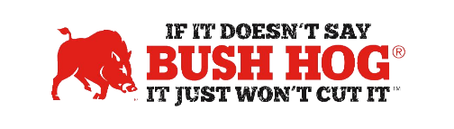
MN Aftermarket Attachments
Contract No. 246978
Expiration Date March 31, 2025

Contract Details
- Contract Name Aftermarket Attachments: Tractors, Compact Loaders, Wheel Loaders,
And Skid Steers
- Contract Number 246978
- Contract Held by Bush Hog LLC
- Multiple Award Yes
- PO Submission Authorized Dealers or Bush Hog
- Coverage Area All MN State Agencies & Cooperative Purchasing Venture (CPV) Members
- Products Covered All products
- Warranty Terms Standard Factory Warranty
- Payment Terms Net 30 Days
- Term of Contract May be extended for up to an additional 48
- Financing Through Dealer
- Trade-In Through Dealer
- Returns Through Dealer

For further assistance, contact your Territory Manager, Shellee Lolley Bullard, Mary Andrews, or Jill Sandidge.

Shellee Lolley Bullard
Customer Service Representative
shellee.lolley@bushhog.com
800-363-6096 ext 3816

Mary Andrews Jill Sandidge
Contract Manager Contract Administrator
mary@manufacturerssolutionsteam.com jill@manufacturerssolutionsteam.com
830-481-4818 615-680-4458

