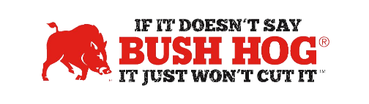
State of Louisiana
Contract No. 4400025797
Expiration Date November 4,2025

Contract Details
- Contract Name Lawn Care/Parts & Accessories
- Contract Number 4400025797 T-Number 92393
- Contract Held By Bush Hog LLC
- Multiple Award Yes
- PO Submission Bush Hog or authorized dealers listed on the contract page LA eCat
- Coverage Area Louisiana
- Products Covered Finish mowers, BH100 Razorback series, landscape equipment,
1812 Flex-Wing mowers, tillage equipment, Bush Hog Parts
Freight Terms Freight, set up and PDI included in price. No additional charges allowed
- Surcharge NA
- Warranty Terms Standard Factory Warranty
- Payment Terms Net 30 Days or P-Card
- Price Changes Allowed Current pricing to be in effect.

For further information, contact your local Territory Manager, Mary Andrews, Jill Sandidge, or Shellee Bullard.

Mary Andrews Jill Sandidge
Contract Manager Contract Administrator
mary@manufacturerssolutionsteam.com jill@manufacturerssolutionsteam.com
830-481-4818 615-680-4458

Shellee Lolley Bullard
Customer Service
Shellee.lolley@bushhog.com
800-363-6096 ext 3816

