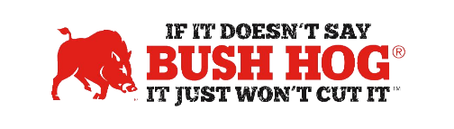
State of Utah
Contract No. KK25-3
Expiration Date December 31,2030

Contract Details
- Contract Name Ground Maintenance Equipment
- Contract Number KK25-3
- Contract Held By Bush Hog LLC
- Multiple Award Yes
- PO Submission Bush Hog or authorized dealers registered in the procurement portal and
approved by the contract administrators.
- Coverage Area Utah
- Products Covered All Bush Hog tractor towed attachments. Bush Hog parts.
- Freight Terms Factory Freight, Set-up, PDI, and local delivery to be added as separate line
item(s). F.O.B. destination with all transportation and handling charges paid for by Contractor
- Warranty Terms Standard Factory Warranty. Repairs made that are covered by a warranty
shall not be paid for by the Eligible User.
- Payment Terms Net 30 Days

Contract Pricing
- Freight Rates Bush Hog Current Rates
- Member Discounts Contact us for the percentage off of MSRP from current price list in effect
at time of order.
- Volume Discount Determined at the time of quoting
- Financing Through Dealer
- Trade-In Through Dealer
- Returns Through Dealer

For further assistance, contact your Territory Manager, Mary Andrews, Jill Sandidge, or Shellee Lolley Bullard.

Mary Andrews Jill Sandidge
Contract Manager Contract Administrator
mary@manufacturerssolutionsteam.com jill@manufacturerssolutionsteam.com
830-481-4818 615-680-4458

Shellee Lolley Bullard
Customer Service
Shellee.lolley@bushhog.com
334-874-2723

